**BlinkIt Market Trends & Customer Insights**

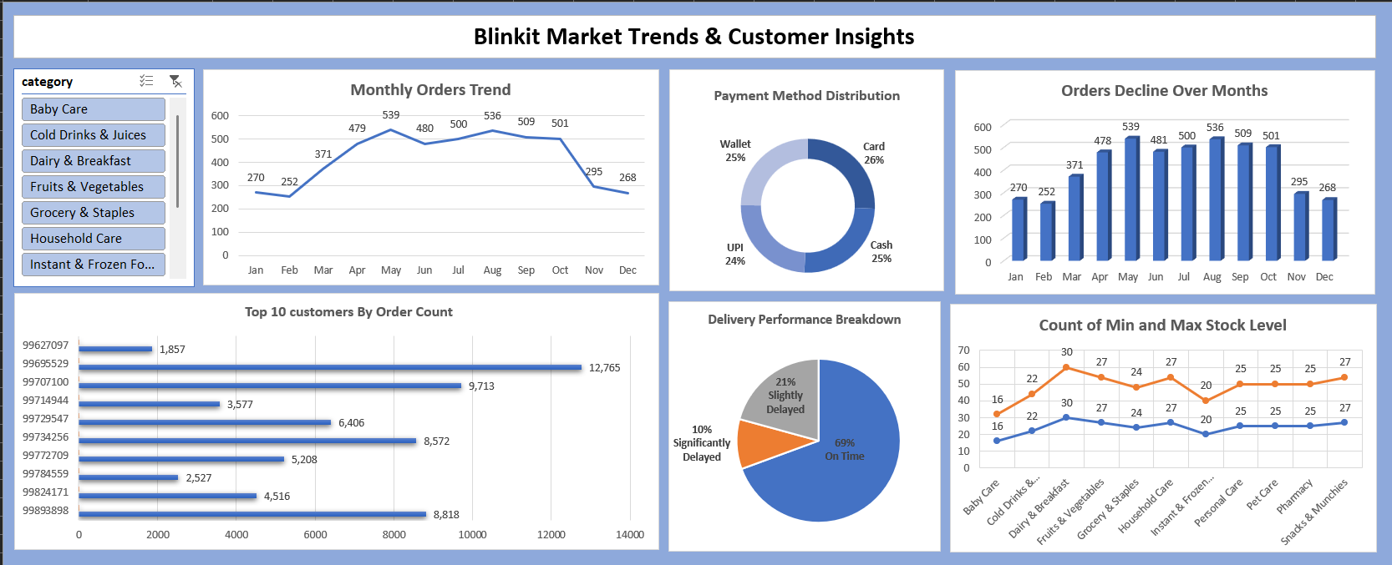

🔍 **Key Insights from the Dashboard:**

📈 **Monthly Orders Trend:** Orders peaked at **539 in May** but showed a decline in later months, reaching **268 in December**. This trend highlights **seasonal demand variations** and helps in forecasting sales.

📊 **Orders Decline Over Months:** The **bar chart** confirms a similar pattern, with a sharp decline after October, indicating potential external factors affecting sales.

💳 **Payment Method Distribution:**

* **Card & Cash payments (25% each)** remain the most preferred, followed by **Wallet (25%) and UPI (24%)**. Understanding this helps optimize payment options.

👥 **Top 10 Customers by Order Count:** A **horizontal bar chart** highlights the most valuable customers, with the highest placing **12,765 orders**. This insight supports **customer retention strategies**.

🚚 **Delivery Performance Breakdown:**

* **69% of orders were delivered on time**, while **21% were slightly delayed** and **10% were significantly delayed**. This helps identify areas for logistics improvement.

📦 **Count of Min and Max Stock Level:**

* The **line chart** showcases fluctuations in stock levels across different categories, helping in **inventory management** and ensuring product availability.

✅ **Business Impact:**

* **Sales Forecasting**: Helps predict demand trends for better inventory planning.
* **Customer Insights**: Identifies top customers and preferred payment methods for targeted marketing.
* **Operational Efficiency**: Tracks delivery performance and stock levels to reduce delays and shortages.